Diaspora Calling
  - Fall 2023
IN THIS EDITION:  Chair’s Note  Department of African & African American Studies  New Faculty Spotlights  Alumni Spotlight  Majoring in AAAS  Course Offerings  10-Point Profile Plan Program  AAAS Core Values  News and Notes | Chair’s Note  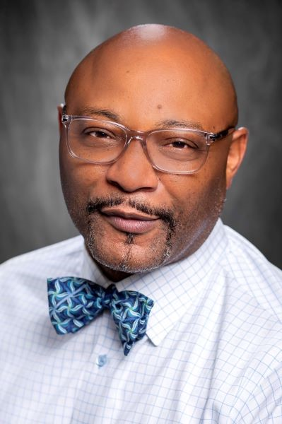  Dear Friends of AAAS:  Welcome back! I hope everyone had a relaxing summer spent doing the things you enjoy the most.  It is such an honor to work with a group of such talented students and scholars. Your commitment to African & African American Studies shows in all that you do to promote research, teaching, and learning.  Photo of Dr. Stephen C. Finley  I wish to thank Dr. Sarah Becker for serving as Interim Chair while I was on sabbatical. Dr. Becker is a wonderful human being and exceeded my expectations leading the unit in my absence.  I truly look forward to yet another productive semester where we highlight the importance of sharing and understanding the experiences of people of African ancestry throughout the Diaspora. I recognize that this task comes with many challenges, including great risks, given the current climate in which we operate. I salute your courage and honor your efforts.  Please join us in welcoming two new faculty members to this struggle, Dr. Teairra Evans, and Dr. Sophie Moore. You can learn more about Drs. Evans and Moore in the current issue. I trust that they will feel the same sense of belonging and support that has been the signature of our unit since it started almost 30 years ago.  Best wishes for a productive semester. I look forward to working with all of you and welcoming you to our new space in Hatcher Hall.  Cheers,  Professor Stephen C. Finley

DEPARTMENT OF AFRICAN & AFRICAN AMERICAN STUDIES
LOUISIANA STATE UNIVERISTY
337 Hatcher Hall
Baton Rouge, LA 70803
Telephone: 225-578–5246
Fax: 225-578–5257
aaas@lsu.edu
INAUGURAL CHAIR  Stephen C. Finley  Associate Professor, African & African American Studies  CORE FACULTY  Teairra Evans  Assistant Professor, Psychology  Lori Latrice Martin  HSS Associate Dean and Professor, African & African American Studies  Sophie Moore  Assistant Professor, Geography and Anthropology  Rogers Orock  Assistant Professor, African & African American Studies  Jas M. Sullivan  Professor, Political Science, Psychology and African & African American Studies  PROFESSOR EMERITUS  Thomas Durant Jr.  EDITOR  Jazmin K. Robinson-Smith  Graduate Assistant, Sociology | AFFILIATE FACULTY  John Bardes, History  Michael Bibler, English  Eldon Birthwright, AAAS  Cassandra Cheney, School of Social Work  Melissa Crawford, Office of Strategic Initiatives  Jonathan Earl, Dean, Honors College  Serap Erincin, Performance Studies  Sarah Franzen, Geography & Anthropology  Tina Harris, Mass Communication  Joyce Jackson, Geography & Anthropology  Catherine Jacquet, History and Women’s, Gender, and Sexualities Studies  Benjamin Khan, History and Women’s, Gender, & Sexualities Studies  Touria Khannous, English  Herman Kelly, AAAS  Ashley Mack, Rhetoric & Culture  Bryan McCann, Rhetoric & Cultural Studies  Ruth Moon, Mass Communication  Roland Mitchell, Dean, College of Education and Human Sciences  LaKeitha Poole, Sports Psychology  Helen Regis, Geography & Anthropology  Raquel Robvais, Communication Studies  Mark Schafer, Sociology  Sonya Wiley, Business  Asha Winfeld, Mass Communication  Alison Young, Art & Design

NEW FACULTY SPOTLIGHT: DR. TEAIRRA EVANS
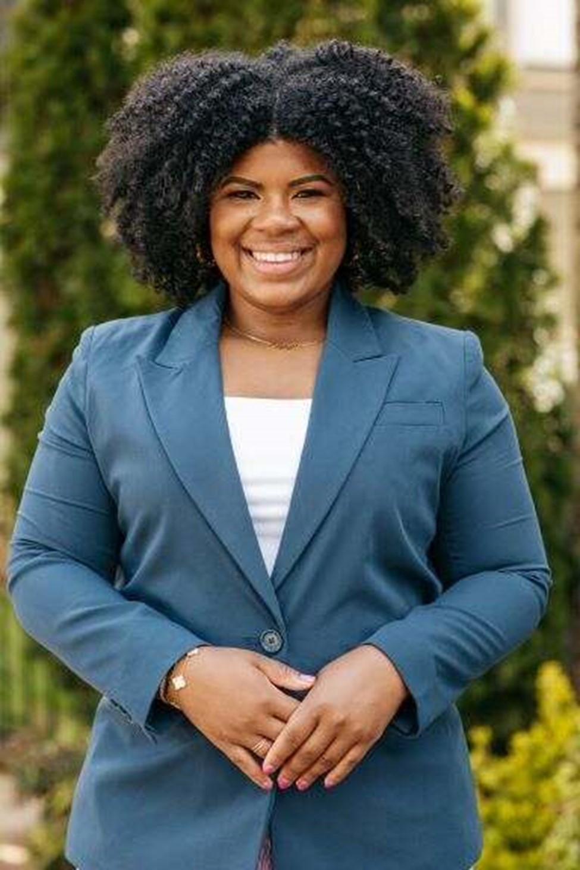
Decision-making is an essential aspect of our everyday existence, encompassing choices ranging from the mundane to the life-altering. These decisions necessitate the evaluation of numerous factors across a range of options. However, engaging in deliberate cognitive processing imposes a burden on our working memory resources, particularly for older individuals. With a decline in working memory capacity as we age, we become more selective in expending cognitive resources and often rely heavily on shortcuts. The focus of my research lies in exploring the impact of cognitive strategies, such as heuristics, on the effectiveness of decision-making in individuals.
Dr. Evan’s research interests include investigating the influence of comprehensibility on the overall quality of decision-making; examining how credibility shapes the decision-making process and its outcome, and exploring the impact of health disparities, specifically diabetes and hypertension, within the African American community on the decision-making process.
Dr. Evans earned a Ph.D. and Masters in Psychology from The University of Alabama. Dr. Evans also earned a M.A. in Women’s Studies and B.S. in Psychology from The University of Alabama.
Photo of Dr. Teairra Evans

Recent publications include:
Mumba, M.N., Jaiswal, J., Bui, C., Evans, T.Z., Mainzinger, L., Davis, L., & Mugoya, G.T. (2022). Substance Use Treatment Services for Older Adults in the Deep South: A State-by-State Comparison of Available Treatment Services. Aging and Mental Health. DOI:10.1080/13607863.2022.2098911
Mumba, M.N., Davis, L., Smith, N.L., Evans, T., Castillo, R. (2022). Effects of Unemployment on Opioid Use Treatment Trajectories: Impact of the COVID-19 Pandemic. Journal of Addictions Nursing. DOI: 10.1097/JAN.0000000000000480.
Black, S., Wood, M., Choi, J., Jackson, B.S., & Evans, T. (2022). Adult Age Differences in Sensitivity to Semantic Satiation. Experimental Aging Research, 48.
Carroll, E., Lerma, K., McBrayer, A., Evans, T., Nathan, S.& White, K. (2021). Abortion Patient Experiences with Protestors While Accessing Care in Mississippi. Sex Res Soc Policy.19:886–893
White, K., Sierra, G., Evans, T., & Roberts, S. (2021). Abortion at 12 or more weeks’ gestation and travel for later abortion care among Mississippi residents. Contraception. 108: 19-24

NEW FACULTY SPOTLIGHT: DR. SOPHIE MOORE
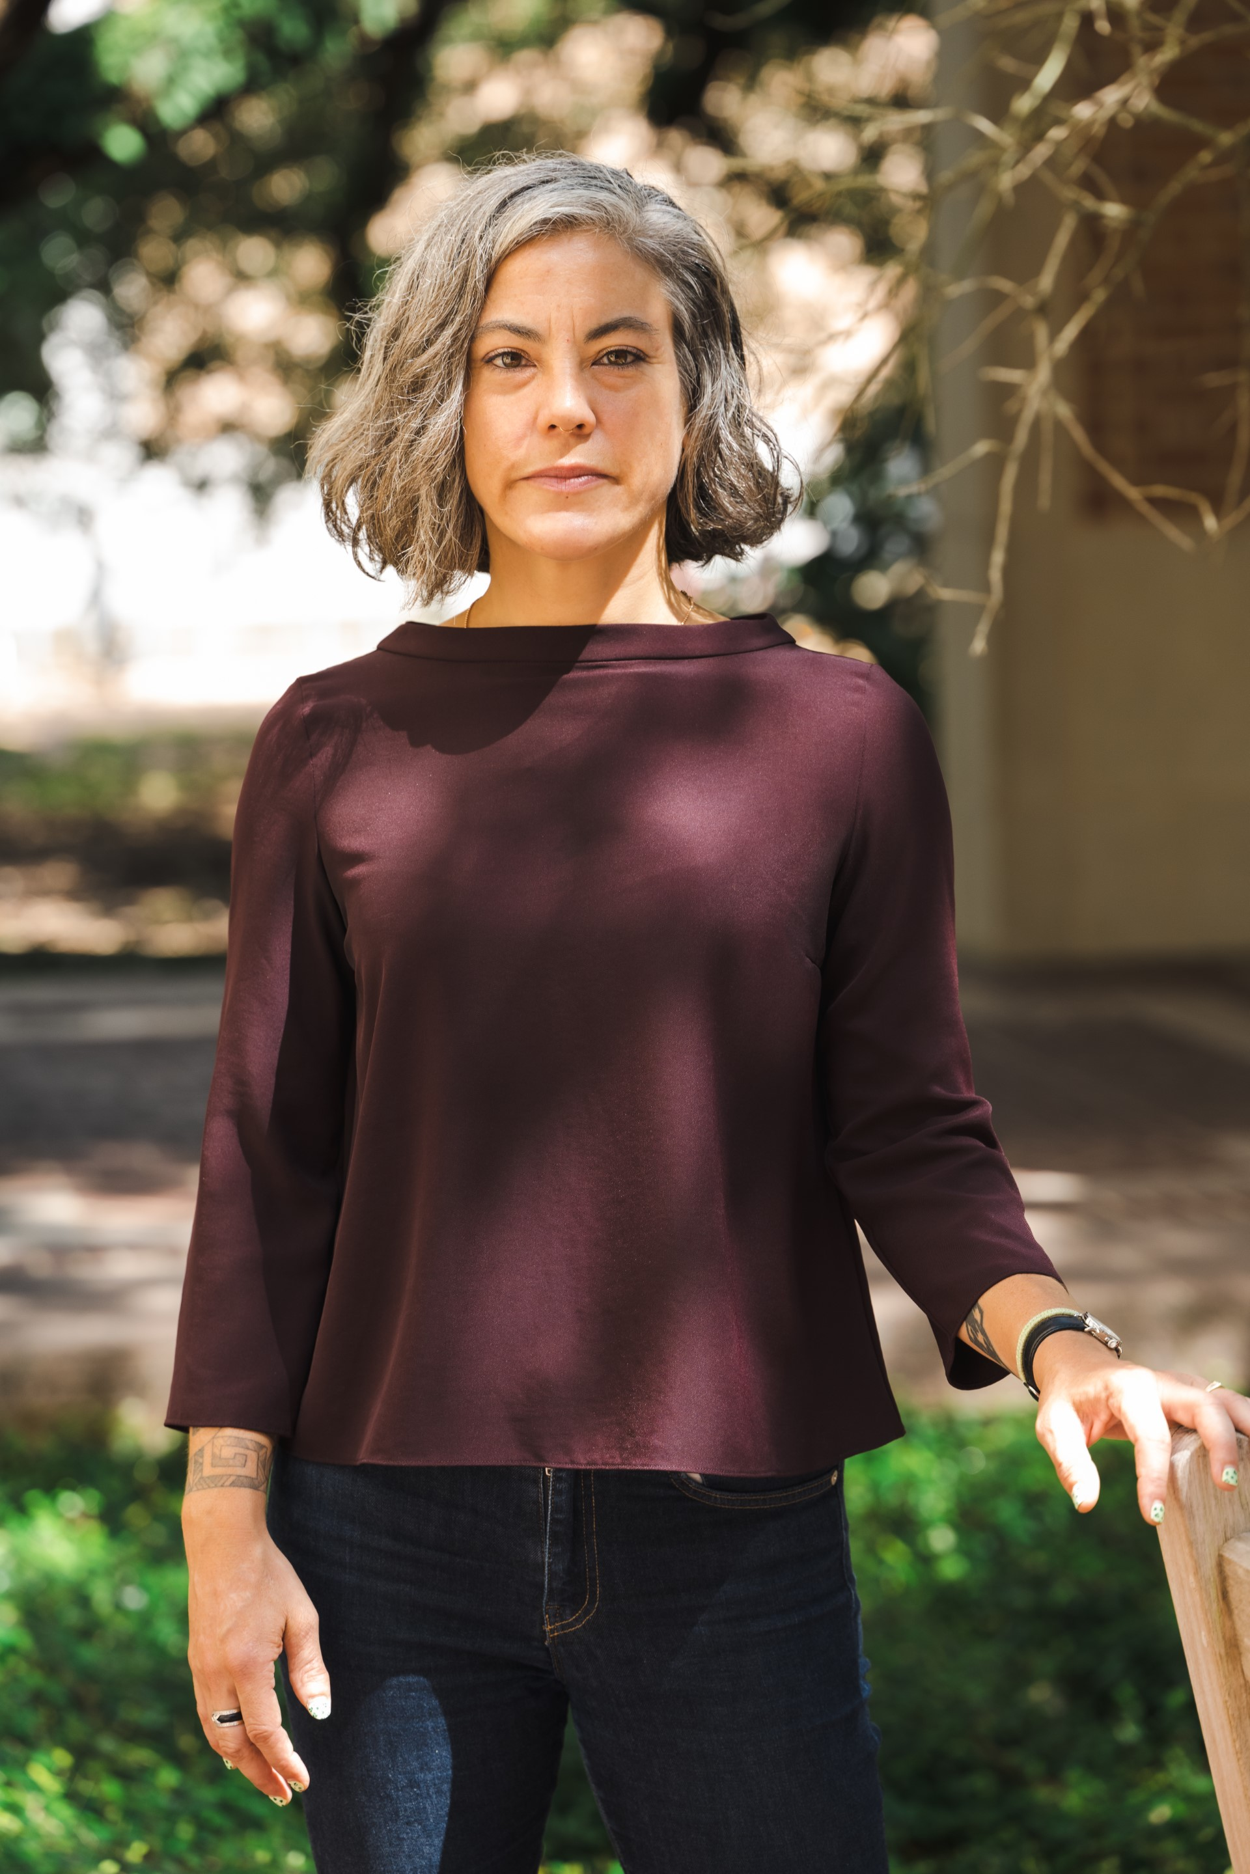
Sophie Moore is an interdisciplinary political ecologist whose research examines intersecting processes of socio-ecological and political change in the Afro-Americas. Moore's current research combines ethnographic and historical approaches to agrarian change and environmental justice in post-plantation geographies. She writes and teaches about formations of race, power, knowledge, and capital in the Caribbean and the Gulf Coast.
Specialty areas: Environmental Justice, Political Ecology, Human Geography, Environmental Humanities, the Caribbean, and Gulf Coast.
Dr. Moore earned a PhD from University of California, Davis, and a MA from San Francisco State University. Dr. Moore also holds a BA from Reed College.

Recent publications include:
Moore, S. and Victoria Koski-Karell. 2023. "Geographies of Empire: Infrastructure and Agricultural Intensification in Haiti." In special issue on "Contours of Environmental Justice in the Caribbean," The Geographical Journal.
Moore, S. 2023. "Cacos and Cotton: Unmaking Imperial Geographies on Haiti’s Central Plateau." Chapter in edited volume Global Plantations in the Modern World: Sovereignties, Ecologies, and Afterlives. (Palgrave Macmillan).
Photo of Dr. Sophie Moore
Moore, S. "Plantationocene." Architectural Review 1485, October 2021: 7-12.
Moore, S., and Aida Arosoaie. "A Syllabus for Plantation Worlds." Edge Effects. Published online 27 May 2021.
Moore, S. 2020. "Between the state and the yard: Gender and political space in Haiti." Gender, Place & Culture. Published online 27 November 2020.
Moore, S., Allewaert, M., Gómez, P., and Mitman, G. Plantation Legacies Edge Effects. Published online 21 January 2019.
Wesner, A., Moore, S., Martin, J., Kirk, G., Dev, L., and Behrsin, I. 2019. “Left Coast Political Ecology: A Manifesto.” Journal of Political Ecology 26 (1): 529–44. (Authors are equal contributors, listed in reverse alphabetical order).
Moore, S. 2017. “Organize or Die: Farm School Pedagogy and the Political Ecology of the Agroecological Transition in Rural Haiti” The Journal of Environmental Education, 48(4): 248–259. Special issue on the political ecology of education.

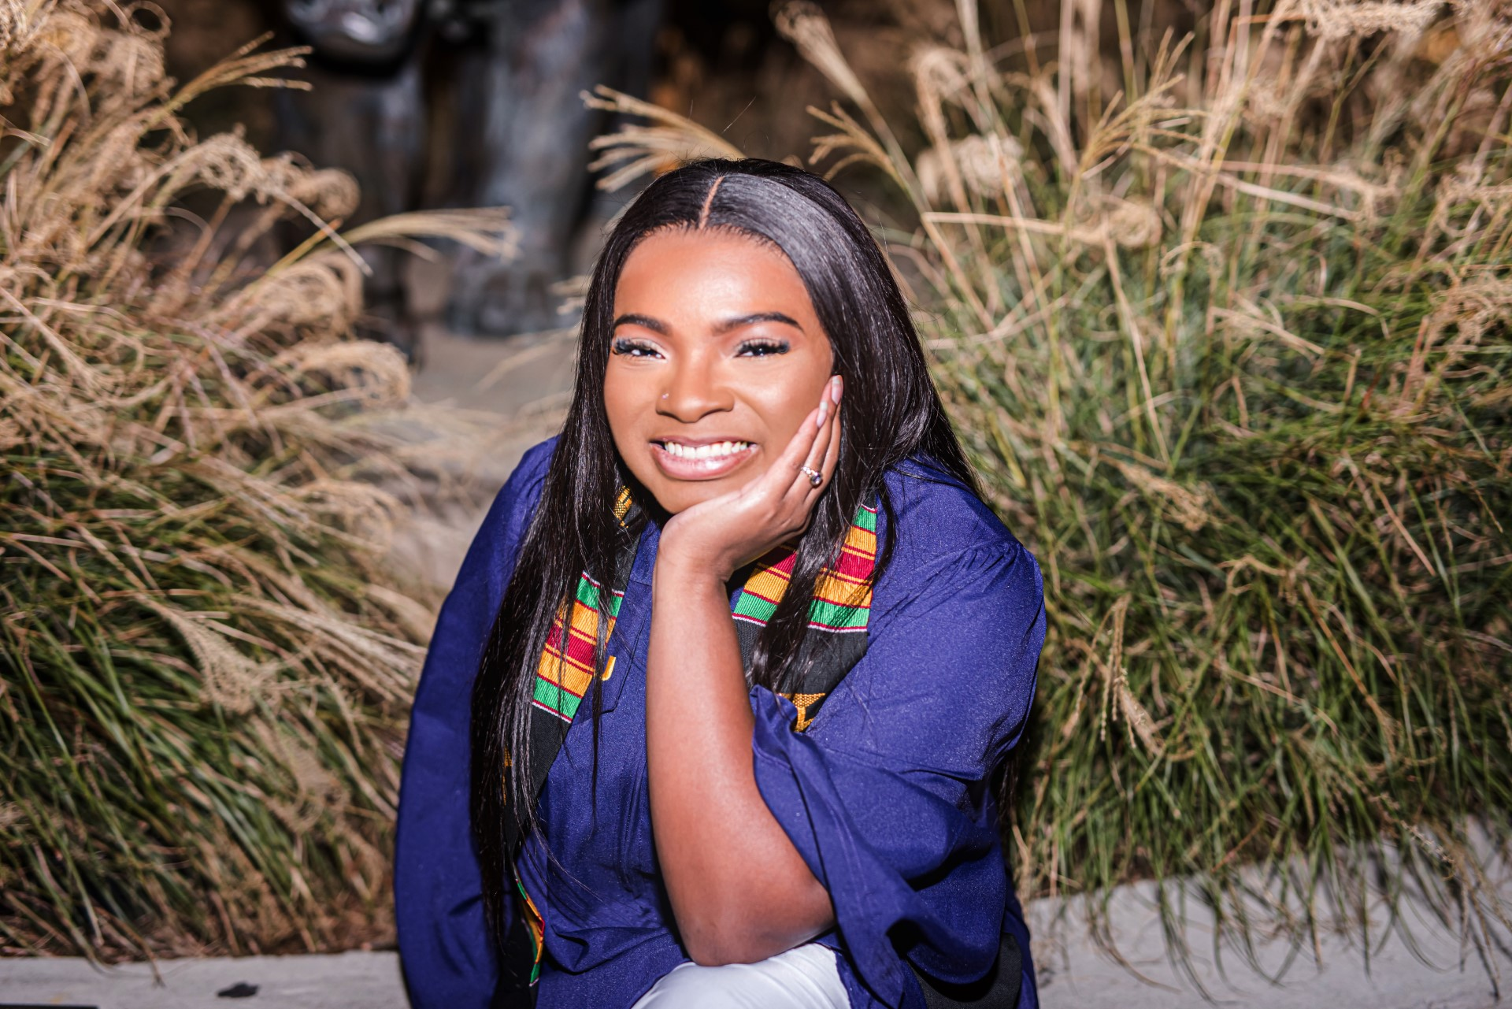
ALUMNI SPOTLIGHT: MAYA JOSHUA
My name is Maya Joshua. I am an alumna of LSU with a degree in Liberal Arts with a concentration in AAAS. Originally coming into LSU, journalism was my game plan until I explored LSU’s website and discovered AAAS.
As a woman of color, AAAS has given me some insight related as to how Black people especially women were treated in society. One of my favorite classes during my studies was “Black Women in America” because I learned various subtopics related to Black women. This class further explained the origin as well as the history of topics. Upon further exploration of the Black women, I learned that the most unprotected as well as neglected people were Black women. This class not only taught how disrespected a Black woman is but also how it has progressed.
Photo of Maya Joshua
As my classes intensified, I learned of the progression of the treatment of Black people in various aspects of life which has influenced me to pursue a career as an attorney. Since my goal and commitment is to become an attorney, I have enhanced my knowledge by gaining a deeper understanding of African and African American history. This has helped and will continue to strengthen my drive to defend Black people. In order for a system to be incorruptible, justice has to stand and symbolize equality for all races in a diverse society. This stems back to the importance of understanding the basic foundation the system should be built on in society. Cases of systemic racism allows AAAS to do remarkable jobs of supplying a variety of topics and viewpoints essential to building a strong foundation for successful outcomes.
As a young Black woman, I intend to implement and utilize my education and degree in this field for the betterment of all minorities to ensure beneficial advantages.
DID YOU KNOW?  A news story on the inception of the new LSU African and African American Studies Department (AAAS) by WAFB has been selected for a Regional Edward R. Murrow Award in the category of Excellence in Diversity, Equity, and Inclusion. It is one of the most prestigious awards in journalism. |  | 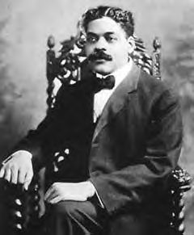  Arturo Alfonso Schomburg, Architect of Black Studies

HOW TO MAJOR IN AAAS
The B.A. in African & African American Studies requires a total of 33 credit hours including:
- A required core of nine (9) hours: AAAS 2000; AAAS 3024 or 3044 (CxC); & AAAS 4020.
- A minimum of six (6) hours must focus on a geographical area outside of the U.S.
- Three (3) hours in a Service Learning or Communication across the Curriculum (CxC) course
- Only twelve (12) hours from courses numbered below 3000-level may count towards a degree.
Sign up today to get started!

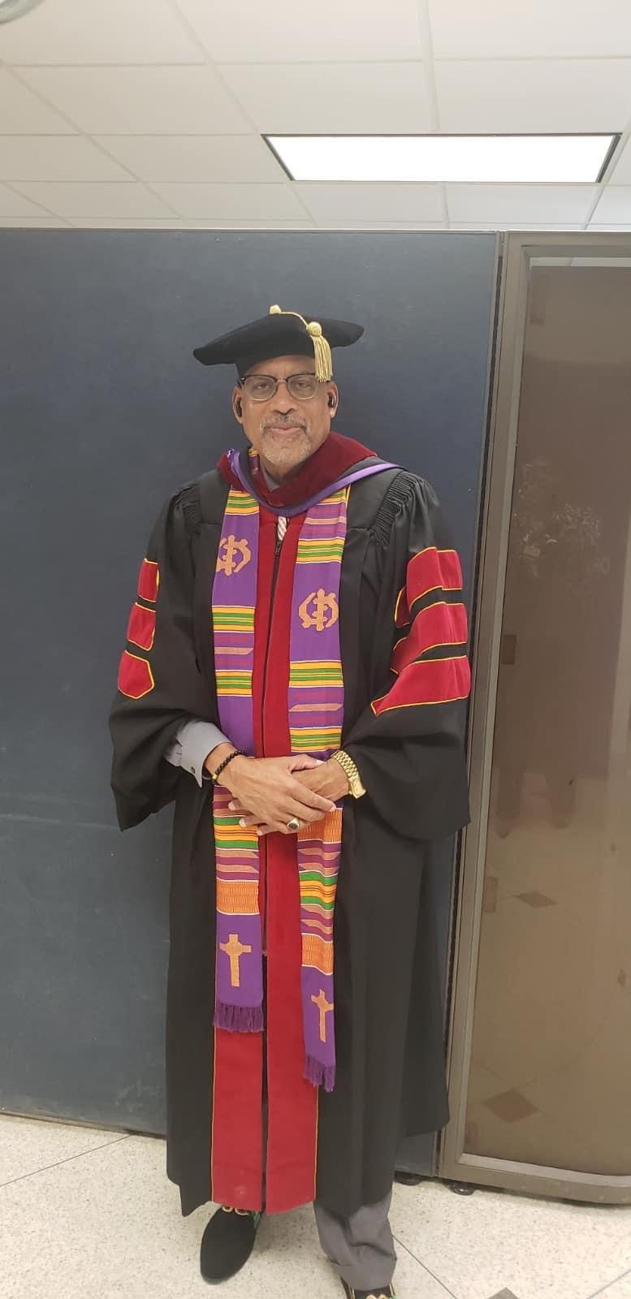

DID YOU KNOW?
The Department of African & African American Studies (AAAS) at LSU is an interdisciplinary unit that promotes critical thinking and challenges students to attain the highest levels of intellectual achievement and personal development through the study of ideas, practices, theories, and experiences of Africans, African Americans, and other diasporic communities.

AAAS Core Values
- Equity. AAAS practices and advocates fair distribution of resources. opportunities. labor, and reward and advocates for the distribution of such in accordance with degree of past harm and present needs.
- Excellence: AAAS strives for the highest distinction and outstanding achievement in scholarship, instruction, professional service, administration, and leadership
- Justice: AAAS works for the transformation of structures, practices, policies, and ideas that inhibit and curtail human flourishing by engaging in self- conscious and ethical treatment of individuals and communities.
- Respect. AAAS shows regard for the humanity of others and honors human difference and sameness.
- Scholarship: AAAS seeks the creation and dissemination of knowledge and socially transformative ideas at highest level of intellectual attainment.

Fall 2023 Course Offerings

Course Number | Course Type | Course Title | Instructor
AAAS 2000.1 | SEM | African & African Studies | Dr. H. Kelly
AAAS 2000.2 | SEM | African & African Studies | Dr. R. Orock
AAAS 2000.3 | SEM Web Based | African & African Studies | Dr. E. Birthwright
AAAS 2000.4 | SEM Web Based | African & African Studies | Dr. M. Pitts
AAAS 2410.1 | Web Based | Black Pop-Culture | Dr. E. Birthwright

AAAS 2511
Cross-listed with SOC 2511
Course Number | Course Type | Course Title | Instructor
AAAS 2511.3 | SEM | Race Relations | T. Evans
AAAS 2511.2 | SEM | Race Relations | D. Dillard
AAAS 2511.1 | SEM | Race Relations | S. Fall

AAAS 3044 to AAAS 3902
Course Number | Course Type | Course Title | Instructor
AAAS 3044.1 | In Class Lecture | Black Rhetorical Tradition | Dr. R. Robvais
AAAS 3120.1 | In Class Lecture | TOPS HST AFR &AFRN | Dr. R. Orock
AAAS 3902.1 | In Class Lecture | Black Psychology | Dr. L. Poole
AAAS 4400 – 4900
AAAS 4400.1 | SEM | MLK & Malcolm X | Dr. S. Finley
AAAS 4900.1 | SEM | Civil Rights | Dr. H. Kelly

10-Point Profile Plan Program

- Develop the Center for Race, Community, and Culture in Louisiana.
- Offer a Master’s Degree Program.
- Offer a Doctoral Degree Program.
- Recruit ten new majors and ten new minors every academic year.
- Raise $5 million for the new department.
- Expand course offerings to include additional cross-listed course and non-U.S. courses.
- Provide professional development opportunities for faculty and students.
- Increase profile of the department within the university, city, region, state, and nation.
- Enhance office space.
- Increase community engagement efforts.

MAJOR WHERE YOU MATTER! ®

NEWS AND NOTES
- Congratulations to Tyler Hunt. Tyler is an AAAS major. Tyler won the “Leading Legacy” NCAAP at LSU award.
- Kudos to Dr. Stephen C. Finley. Dr. Finley was featured on Left of Black, an award-winning podcast at Duke University. Dr. Finley discussed his latest book on the Nation of Islam. https://www.youtube.com/watch?v=3oe_Jj8ZOMU
- Doctoral student, Justin Martin, was selected as the recipient of the AAAS Changemaker Award for the 22-23 academic year for his dedication to the AAAS community.
- Angel Puder was honored as recipient of the Outstanding Undergraduate AAAS Major Award for the 22-23 academic year. Angel was recognized for her commitment to recruitment among other achievements.
- AAAS major Kiersten Simon was awarded a summer internship at the Smithsonian National Museum of African History and Culture in Washington, DC.
- AAAS new affiliates: Drs. Bastien Craipain, Brittany Cook, Casey Patterson, and Peter Cava!
- Coming Soon: AAAS 30@30 Anniversary Campaign (1994-2024)

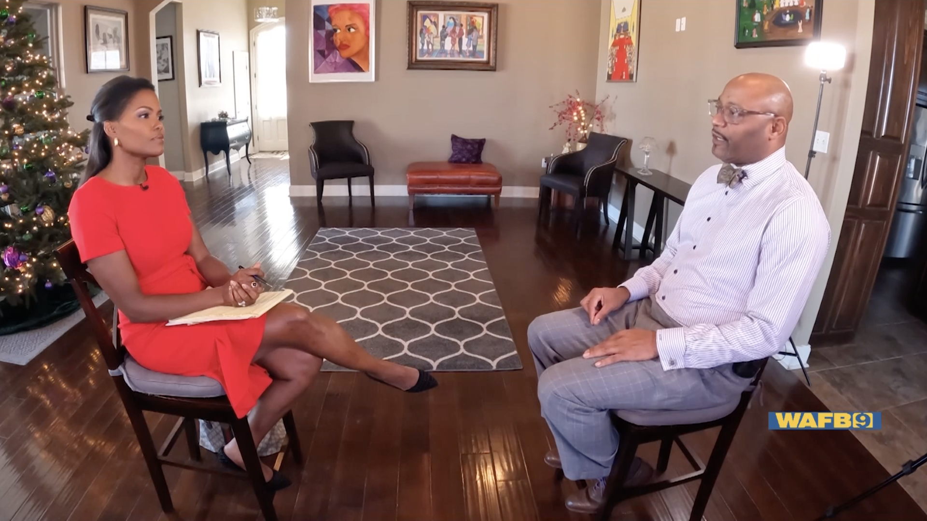
Dr. Stephen C. Finley and WAFB Anchor and Reporter Tisha Powell

