Student Learning Assessment: Program Impact Report (PIR)
Fall 2021 – Spring 2024
(Years 2021-22, 2022-23, 2023-24)

College of Human Sciences and Education

Degree Program: MEd in Counseling and EdS in Education – Counseling

The LSU Counselor Education program is a 60-hour master's degree program in counseling with two distinct concentrations: Clinical Mental Health Counseling and School Counseling. The degree prepares all students to function as professional counselors in a variety of human service settings such as schools, college counseling centers, mental health treatment facilities, and private practices. Our program prepares students to meet the mental health needs of clients in the state of Louisiana and nationally. Our goal is to prepare students to master the knowledge and skill areas specified by current preparation standards and best practices in the counseling profession. Graduates use their knowledge and skills to help individuals, couples, and families from diverse backgrounds to enhance life adjustment, foster personal growth and wellness, promote social justice and advocacy, and expand competencies in coping with environmental demands across the lifespan.

We revised and streamlined our program mission statement due to our accreditation standards (CACREP 2016) and reflecting our vision for our program. The new mission statement is:
The LSU Counselor Education program prepares students to meet the mental health needs of diverse clients in Louisiana, and nationally, through a focus on evidence-based practices, advocacy and social justice, and wellness across the lifespan.

In Fall 2023 we reviewed both concentrations in terms of the mission statement and objectives. We updated some of the wording in our objectives to better reflect current terminology in the field. Our revised program objectives include:
To prepare our students with experiential and didactic learning opportunities to acquire the knowledge, skills, and dispositions required of an effective professional counselor, upon completion of our program students will be prepared to:
a. Practice according to the codes of ethics, legal precedents, and professional standards of the counseling profession.
b. Provide counseling services in a diverse and multicultural society;
c. Work effectively with individuals, couples, families, and groups across the lifespan to improve their mental health and wellbeing;
e. Demonstrate excellent helping, communication, conflict resolution, consultation, and other intrapersonal and interpersonal skills;
f. Design and facilitate group interventions to serve clients in various settings;
g. Select, administer, and interpret assessment tools as appropriate and ethical to their counseling settings;
h. Utilize a variety of research methods, statistical procedures, needs assessments, and program evaluations designed to improve counselor effectiveness; and
i. Demonstrate a professional counselor identity appropriate to their chosen career path.

Over the past year several changes have been implemented to revise curricular offerings to optimize student learning:

- OIE feedback: Per feedback from LSU’s Office of Institutional Effectiveness, we revised our program objectives (listed above) so that those referring to improving knowledge are stated more behaviorally. In 2024-2025 we are working to align our program, student resources, and teaching materials to these new objectives.

- Program of Study Sequence: The faculty reviewed the program of study to look at course sequencing, especially for the third year in the program. One problem has been that our current sequence only requires 6 credit hours for each of the last two semesters. This has been an issue for those students with assistantships as they need to take 9 hours to maintain their assistantship positions. One option is to remove summer courses and move those to Fall and Spring of the final year. This would also allow students and faculty summer breaks, study abroad opportunities, and students could take electives during summer in other programs. In addition, by moving content courses (e.g., Analysis of the Individual, Vocational Counseling) to the Fall of Year 3, it is possible scores on the CPCE Exam will be higher for graduating students as students who are working with clients may have a better, deeper understanding of the content provided in those difficult content courses.

- Elective Offerings: Due to a reduced number of faculty, we will look at course offerings throughout the college and university to optimize potential elective courses that meet student interest during years 1 and 2 in the program and in summertime (e.g., an elective in Sport Psychology or Motivation and Behavior). We also identified some courses that might be offered every other year to maximize enrollments and offer cross-cohort interaction and support.

- REVISED Courses: In Spring 2024, Dr. Csaszar began teaching Group Counseling and revised the entire curriculum based on feedback received on the course with the previous instructor. A minor revision to ELRC 7345, Counseling Skills, included more suicide assessment, based on site supervisor and graduate feedback, using the model IS PATH WARM?

- Dispositional Reviews: Another change implemented in 2023 was a change in our procedure for assessing student dispositions. We started with the removal of the Student Academic, Professional and Personal Development Review from our Counselor Education Program Handbook. We replaced it with the Professional Dispositions Competency Assessment—Revised (PDCA-R) (Non-Admissions Form) (Freeman & Garner, 2017) (see also Garner et al., 2020). The reason for the change was to focus on measuring dispositions per CACREP standards and to use a valid and reliable measure. We piloted the dispositional reviews with our first-year cohort in Spring 2023. Faculty members corroborated scores for everyone in the Year 1 cohort in Spring 2023, and subsequently provided individualized feedback to students by subcommittees. In Spring 2024 we did a second round of dispositional review feedback with our 2025 graduates and completed a first round of feedback for our Year 1 cohort (2026 Graduates). Based on results of the PDCA-R implementation over two years, we noted that students in the Year 2 Cohort (May 2025 Graduates), had overall improved scores from Year 1 ($X$ = 3.4) to Year 2 ($\overline{X}$=4.2; +.8 over Year 1) demonstrating dispositional growth through their time in the program. Please see Table 1 and Table 2 for Dispositional Review Data for Graduates of 2025 and 2026 respectively.

- Increased financial support for students: In our Fall 2023 review meeting, we noted an increase in out of state applicants, admits, and out of state student enrollment in the program. While the diversity of the applicant pool should still be improved, as our applicants are overwhelmingly female, White, and from social sciences majors, we have been successful in recent years in increasing the diversity of the students who enroll in the program. The LSU Graduate School offers tuition exemption to students from under-represented groups, which helps with recruitment, and faculty are active in attempting to secure Graduate Assistantships for students with offices across campus, including counseling-related positions such as Offices of Student Services in various Colleges across campus, Career Services, Disability Services, and Campus Life Offices. We surveyed students in our program in Spring 2023 and 2024 regarding assistantships. In 2023, 28 of our students had assistantships. In 2024, all 55 students in the program responded to the survey. Of those, 32 had assistantships on campus; additionally, seven students have full-time campus jobs, and six students were seeking assistantships. However, one of the six seeking an assistantship had a paid internship in a school setting. This means, only 5 students out of 55 were seeking an assistantship unfunded. For a list of student assistantships in the 2023-2024 academic year please see Table 3. Results of the GA survey by cohort are in Table 4.

- Crisis and Trauma Counseling Course: In summer 2025 a Crisis and Trauma course was provided in the summer with an in-house expert. Haley Shows, a LPC, who has run the Suicide Hotline, taught the course for our program. Student interest was high (28 enrolled). Drs. Curry and Csaszar have met with Ms. Shows and plans to continue offering the course are underway.

- Ethical Case Studies on AI: Students in Couples Counseling and Counseling Across the Lifespan participated in an Ethics project using Generative Artificial Intelligence (AI) to better understand how to critically assess AI use in counseling case work in Fall 2023. Results were published by Csaszar and Curry.

- Self-Reflection: In ELRC 7393 Family Counseling, self-reflective activities were added to help students recognize personal family issues.

- Adjunct Onboarding: We have updated our adjunct training to better onboard outside faculty, based on exit survey data, with our program philosophy and training expectations to enhance the student experience. Dr. Csaszar is meeting with all adjuncts for onboarding.

- We conducted formal exit studies of program graduates to assess graduate perceptions and evaluations of major aspects of the program.
Students complete an exit survey at the conclusion of their last semester in the program. The survey asks students to rate advising, accessibility of faculty, quality of instruction and clinical experiences, and extent to which they felt prepared to enter their careers. The Likert-type scale ranges from 1-5 (strongly disagree to strongly agree). Ratings indicated that students graduating in Spring 2024 felt highly prepared ($\overline{X}$= 4.80). In addition, the quality of instruction and clinical experience provided by counseling faculty was rated as a moderate strength. Instruction by outside faculty was rated lowest ($\overline{X}$= 4.80. Although we try as a faculty to find diverse adjuncts with exceptional experience, adjuncts are rarely well received by students as they often do not emit the same commitment to teaching or demonstrating knowledge of research within the field. Another low area was accessibility of faculty advisors ($\overline{X}$= 3.67). As the data is based on student perceptions for one cohort, we are unsure why students felt this way although we can surmise a few things. At the time of graduation for this cohort when we collected this dataset, we had one faculty member (Eberts), one was moving to retirement (Gintner), one was on sabbatical (Curry), and one was in administration (Choate). This left one core faculty member doing most of everything in Spring 2024. Positive comments about the program from students included:
- The flexibility and structure of the program
- A strong sense of community within the cohort
- Professors are understanding, empathetic, and supportive
- High-quality clinical experience with excellent supervision
- Experiential learning and practical applications in courses
- The breadth and depth of the curriculum, particularly in core classes and internship
- Faculty's investment in student growth, support, and accessibility
Suggestions for improving the program included:
- Improved process for finding and securing practicum/internship sites
- More trauma and suicide prevention training
- Consistent and regular advisement meetings with faculty
- Greater emphasis on professional development skills such as marketing and resume building
- Inclusion of more elective courses and diverse therapeutic techniques
Some of the suggestions were things beyond the control of the Counselor Education faculty. For example, adding electives is not something our program can do due to limited faculty and accreditation constraints. We do allow students to take elective courses on African American studies, LGBTQIA, sport psychology, etc. from other faculty across campus when available. Suggestions we can address include increasing access to trauma and suicide prevention. In 2024 Dr. Csaszar (new program leader) implemented group program advisement by cohort year. We will extend this model to ensure semesterly meetings. Dr. Csaszar also provided all incoming students with an individual faculty member to serve as their advisor. The university has a resume building opportunity through the Olinde Career Center. We will pursue ensuring that students are doing resume review at Olinde.
- We conducted formal studies of site supervisors and program graduate employers that assess their perceptions and evaluations of major aspects of the program.

  - Site Supervisors: We collect feedback from site supervisors at our annual Site Supervisor Workshop (held each spring) and on our student evaluation forms. We ask site supervisors the question, “What can we do to better prepare students for their experiences at your site?” See Table 6. for actual site supervisor comments. Many supervisors commented on the quality of preparation of LSU students. Some of the supervisors asked that we consider offering on-site electives; better training on suicide; and for school counselors, a better understanding of the overall role of the school counselor from the site supervisors’ perspectives. Somewhat problematic is that school counselor supervisors tend to recommend that we train our school counseling students to serve in an antiquated model of school counseling (guidance services) and to do activities outside the role of a school counselor based on the ASCA National Model (2019). Although we do review their recommendations, we don’t want to change our program to counter current standards. See Table 6 for site supervisor comments gathered from the CCSS in Practicum and Internship. See Table 7 for site supervisor comments gathered from the Site Supervisor Workshop held in Spring 2024.

  - Employers: An employer survey is sent bi-annually. The Spring 2023 employer survey asked about both knowledge and skills of employees hired who are graduates of the LSU Counselor Education program. On average, employers had 4.25 employees from the program and were asked to rate the skills and knowledge of their most recent hires on a scale of 1-10. Items consisted of skills and knowledge within the eight CACREP core areas. Employers rated our graduates between 9-10 in a 1-10 range (10 being the highest) on EVERY item. On average employers rated students very favorably in most skill areas (see Table 8 for results).

  - Alumni: We conducted a bi-annual survey of alumni in 2023 to request feedback on the LSU counselor education program. We asked year of graduation, concentration (i.e., CMHC or School Counseling), what type of work they were currently doing, starting salary, promotions, current employer and contact, any special achievements they had since graduating from the program, ratings of the program in professional skills and knowledge. Alumni had the opportunity to share strengths of the program and areas of improvement. Alumni from the last five years were surveyed and 46 responded to our questionnaire. All alumni reported special achievements including types of licensures earned (e.g., state licensure (LPC), LPC-S, various certifications (NCC, NCSC) and others), doctoral degrees, department chair, district school counselor of the year, Recognized ASCA Model Program award (RAMP), PhD, and having presented on counseling topics at state and national conferences. Alumni specialized in a wide range of counseling including sexual trauma, domestic violence, couples counseling, career counseling, sexual offender treatment, perinatal mental health, restorative justice, substance use, and play therapy. All respondents had collegial relationships, and many were currently networking with prior classmates. In summary, alumni generally reported a positive, favorable review of the program. See Table 9 for Alumni Survey Combined Comments.

- We assessed student learning and performance on professional identity, professional practice, and program area standards.

In previous years we noticed a tendency for CCSS scores to appear inflated; particularly from site supervisors and new site supervisors specifically. To mitigate this trend, we reviewed the Likert range of possible CCSS scores (1-7) and decided that given our target range is 3-5 and that students in that range have an acceptable score, we would ask that ANY score below or above that range would need justification. We piloted this revised CCSS in Counseling Skills and Practicum in In Fall 2023 and Spring 2024. Scores fell in a more normative range in those semesters. See results descriptions in the CCSS section below.
CPCE
Our summative measure is the Counselor Preparation Comprehensive Examination, a national counseling exit exam. It has eight subscales that are aligned with outcomes 1-8. In addition, a mean composite total score (combining the eight subscales) was calculated and compared to a national mean score Results indicated that the LSU raw composite score and mean (∑=98.25; $\overline{X}$= 12.28) was significantly higher than the National raw composite score and mean respectively (∑=87.36; $\overline{X}$= 10.91). In addition, LSU students scored higher across all eight subscales than the national average (see Table 10). Table 10 shows individual raw scores for the graduates of 2024, subscale summary data, and LSU and National subscale means. Because National mean scores change each year with varying iterations of the CPCE, we have chosen to always have an intended outcome of exceeding the National mean score by 1.0 quality point on each subscale. For 2024, our students did this on the composite score and on six out of eight subscales (excluding development and career, which were nearly 1.0 higher). Figure 1. depicts the LSU and national subscale means.
CCSS
The program also assesses skills annually through clinical performance. The Counseling and Counselor Scale (CCSS) is a formative measure that assesses counseling skills, professional behaviors, and other counseling competencies. It is administered each semester starting in Fall of the student’s second year as part of the Counseling Skills class (competencies 1-5 only), Practica courses, and Internships. The rating scale is completed by the LSU faculty supervisor and the site supervisor. As previously noted, the scale was revised, and the revised scale was implemented for Practicum in Spring 2023 as a pilot. In Fall 2023 all site supervisors and university supervisors in Internship used the revised scale. We hope this will keep scores at a more normative range (3-5) and decrease inflated scores (6-7).
Our program outcomes have consistently met and often exceeded our targets. In terms of the CCSS, throughout 2023-2024 program targets were met and often exceeded ideal. Data consistently showed improvement from midterm to end of semester ratings, using both faculty and site supervisor ratings. Over the 2023-2024 academic year the faculty also worked with site supervisors about how to rate this measure so that there would be greater consistency between faculty and site-supervisors.
Counseling Skills Outcomes
In Fall 2023 in Counseling Skills, only one measurement of Counseling Skills was taken by faculty supervisors and this rating becomes a program baseline for the cohort over 2 years. Only subscales 1-5 are measured as session deepening is not possible since students generally only have 1-2 sessions with clients at most. For the 2nd year cohort, the composite subscale score for both Counseling Skills sections $\overline{X}$=4.33, which exceeds our target score. See Table 11.
Practicum
For School Counseling practicum in Spring 2024, the faculty midterm composite CCSS $\overline{X }$score = 4.54 while the Site Supervisor midterm composite CCSS $\overline{X }$e = 4.43. The total School Counseling midterm composite CCSS $\overline{X}$score = 4.49. For School Counseling practicum in Spring 2024, the faculty final composite CCSS $\overline{X }$score = 5.02 while the Site Supervisor final composite CCSS $\overline{X }$score = 4.80. The total School Counseling final composite CCSS $\overline{X}$score = 4.92. See Table 12. Thus, scores were closely aligned. For CMHC practicum in Spring 2024, the faculty midterm composite $\overline{X}$score = 4.54 while the Site Supervisor midterm composite CCSS $\overline{X }$score = 4.44. The total CMHC midterm composite CCSS $\overline{X }$score = 4.49. For CMHC practicum in Spring 2024, the faculty final composite CCSS $\overline{X }$score = 5.28 while the Site Supervisor final composite CCSS $\overline{X}$score = 4.90. The total CMHC final composite CCSS $\overline{X }$score = 5.09. As aforementioned, Spring 2024 Practicum was the second(?) semester the revised CCSS was used. Students in Practicum showed growth exceeded the target score and over their scores in Counseling Skills. See Table 13.
Internship
For School Counseling internship in Fall 2023, the faculty midterm composite CCSS $\overline{X }$score = 4.53 while the Site Supervisor midterm composite CCSS $\overline{X }$score = 4.90. The total School Counseling midterm composite CCSS $\overline{X }$score = 4.71. For School Counseling internship in Fall 2023, the faculty final composite CCSS $\overline{X} s$core = 4.95 while the Site Supervisor final composite CCSS $\overline{X}$score = 4.78. The total School Counseling final composite CCSS $\overline{X}$score = 4.87. See Table 14. For School Counseling internship in Spring 2024, the faculty midterm composite CCSS $\overline{X}$score = 5.28 while the Site Supervisor midterm composite CCSS $\overline{X}$score = 5.33. The total School Counseling midterm composite CCSS $\overline{X}$score = 5.30. For School Counseling internship in Spring 2024, the faculty final composite CCSS $\overline{X}$score = 5.82 while the Site Supervisor final composite CCSS $\overline{X}$ score = 5.83. The total School Counseling final composite CCSS $\overline{X}$ score = 5.82, again, exceeding the target. See Table 16.
For CMHC internship in Fall 2023, the faculty midterm composite CCSS $\overline{X}$score =4.65 while the Site Supervisor midterm composite CCSS $\overline{X}$score = 4.84. The total CMHC midterm composite CCSS $\overline{X}$score=s 4.74. For CMHC internship in Fall 2023, the faculty final composite CCSS $\overline{X}$ score = 5.15 while the Site Supervisor final composite CCSS $\overline{X}$ score = 5.01. The total CMHC final composite CCSS $\overline{X}$score = 5.08. See Table 15. For CMHC internship in Spring 2024, the faculty midterm composite CCSS $\overline{X}$score = 4.99 while the Site Supervisor midterm composite CCSS $\overline{X}$ score = 5.35. The total CMHC midterm composite CCSS $\overline{X}$ score = 5.17. For CMHC internship in Spring 2024, the faculty final composite CCSS $\overline{X}$score = 5.49 while the Site Supervisor final composite CCSS $\overline{X}$score = 5.57. The total CMHC final composite CCSS $\overline{X}$score = 5.53, above the program target. See Table 17.
Commentary on specific course content and pedagogical changes to come:
- For ELRC 7345 Counseling Skills, a Theater department first-year course was identified as a partner course. The students in the Theatre course served as counseling subjects for counseling session video recordings. We piloted this partnership in Fall 2022 and continued in Fall 2023. This allowed earlier real-life counseling experience with a first-year college population. However, we found it difficult to reliably schedule this population and will now partner with a different course in Fall 2024 based on student feedback. The new course is Social Work 3003, a miniskills course.
- In ELRC 7345, Counseling Skills, and in ELRC 7391, Counseling Across the Lifespan, students will participate in mandatory service-learning. This is to promote a greater sense of efficacy for serving clients through earlier exposure in the program.
- In practicum and internship, a refresher on the use of assessment measures as part of the student's case formulation and treatment planning activities was added. This included a review of behavior and symptom measures that were introduced in ELRC 4600 Disabling Conditions, ELRC 7348 Substance Abuse and ELRC 7333 Analysis of the Individual.
- Students in Couples Counseling and Counseling Across the Lifespan participated in an Ethics project using Generative Artificial Intelligence (AI) to better understand how to critically assess AI use in counseling case work in Fall 2023. Results were published by Csaszar and Curry.
- In ELRC 7334 Vocational Counseling, Counseling Across the Lifespan, and Counseling Skills, students are now required to participate in wellness interventions as an increased focus on contemplative pedagogy. This is due to previous student feedback, alumni, and site supervisor feedback. We are using the Mindspa created by our faculty and implementing meditation in numerous classes to bolster mindfulness practices. Results of three semesters of interventions were presented at the International Association for Counseling. One Mindspa session show significant reductions in stress so we will continue to use this
- In ELRC 7393 Family Counseling, self-reflective activities were added to help students recognize personal family issues.
- We have updated our adjunct training to better onboard outside faculty with our program philosophy and training expectations to enhance the student experience. Dr. Csaszar is meeting with all adjuncts for onboarding.
- Per site supervisors, exit interviews, alumni surveys, and student feedback, we plan to infuse more training for the school counseling students in classroom management, IDEAs, 504 plans, and twice exceptionality (2E). Because this will require additional content coverage, students will cover these in modules introduced during internship beginning in Fall 2023.
- Our program will choose an overarching suicide model to teach across the curriculum beginning in Fall 2024.

Table 1. Annual Disposition Review for Graduates of 2025
De-Identified Student Names | Year 1 Dispositional Score 2023 | Year 2 Dispositional Score 2024 | Difference from Year 1 and 2 +/-
Student 1 | 3.5 | 3.9 | +0.4
Student 2 | 2.85 | 3.6 | +0.75
Student 3 | 3.0 | 3.8 | +0.8
Student 4 | 3.1 | 3.8 | +0.7
Student 5 | 4.0 | 4.9 | +0.9
Student 6 | 3.8 | 4.1 | +0.3
Student 7 | 3.6 | 4.0 | +0.4
Student 8 | 3.4 | 4.7 | +1.3
Student 9 | 3.1 | 4.3 | +1.2
Student 10 | 3.0 | 3.7 | +0.7
Student 11 | 3.3 | 4.8 | +1.5
Student 12 | 3.2 | 3.9 | +0.7
Student 13 | 3.6 | 4.5 | +0.9
Student 14 | 3.1 | 4.3 | +1.2
Student 15 | 3.1 | 4.7 | +1.6
Student 16 | 3.3 | 3.8 | +0.5
Student 17 | 4.4 | 5.0 | +0.6
Student 18 | 3.1 | 3.6 | +0.5
Student 19 | Student on LOA | 3.9
TOTAL | 60.5 | 79.3
Mean | 3.4 | 4.2 | +.8

Table 2. Annual Disposition Review for 2026 Graduates
De-Identified Student | Year 1 Dispositional Score 2024
Student 1 | 3.7
Student 2 | 4.0
Student 3 | 3.7
Student 4 | 3.6
Student 5 | 3.7
Student 6 | 3.7
Student 7 | 4.0
Student 8 | 4.0
Student 9 | 4.0
Student 10 | 3.7
Student 11 | 3.8
Student 13 | 3.7
Student 13 | 3.8
Student 14 | 3.3
Student 15 | 3.6
Student 16 | 3.5
Student 17 | 3.6
Student 18 | 3.6
Student 19 | 3.7
Student 20 | 3.6
TOTAL | 74.3
Mean | 3.7

Table 3. Reported Assistantships Held by Students in Counselor Education in 2023-2024
2023-2024 Assistantships
Counselor Education | Chevron Center for Engineering Education | College of Engineering- Diversity Initiatives | Disability Services | Advocacy, Collaboration and Engagement Office
Cox Academic Center for Student Athletes | School of Education - RA for Dr. Estanislado Barrera | School of Education – RA for Early Childhood Education Oral History Project | Graduate School - Docs & Records Unit | Shell Tutorial Center for the Center for Academic Success
The Intercultural Center | School of Education GA support role | Carts-Center for Analytics & Research In Transportation Safety | LSU Women's Center / LGBTQ+ Center | College of Human Sciences and Education
Center for Academic Success | Center for Academic Success | College of Human Sciences & Education: Student Services GA | College of Engineering | College of Human Sciences and Education - Research Assistant for Dr. Jennifer Curry
Leadership Development Institute | Disability Services | Disability Services | School of Education - PRISE GA | College of Human Sciences & Education: Student Services GA
Center for Academic Success | T Harry Williams Center for Oral History - LSU Libraries | School of Education (Communications GA) | School of Education — RA for Dr. Blanchard | School of Education – RA for Dr. Kennedy

Table 4. Awarded Assistantships by Cohort Year
Cohort | # of students with assistantships | # of students who work  Full or part-time (not seeking assistantship) | # of students seeking assistantship | Total responses to survey
3rd Year Cohort (May 2024 Graduates) | 12 | 4 | 0 | 16
2nd Year Cohort (May 2025 Graduates) | 10 | 6 | 3 | 19
1st Year Cohort (May 2026 Graduates) | 10 | 7 | 3 | 20
Total | 32 | 7 | 6 | 55

Table 5. Student Exit Survey Data
 | Exit Questionnaire – Spring 2024
 | 1. Accessibility of Faculty Advisor | 2.Accessibility of instructors | 3. Quality of advising | 4. Instruction by Counselor Ed Faculty | 5. Instruction by other faculty | 6. Quality of Counselor Ed courses/ Clinical Experience | 7. Quality of courses/clinical experience outside of Counselor Ed | 8. Extent to which you feel prepared to work
Student 1 | 5 | 5 | 5 | 5 | 5 | 5 | 5 | 5
Student 2 | 5 | 4 | 5 | 3 | 2 | 4 | 2 | 5
Student 3 | 4 | 4 | 3 | 5 | 1 | 4 | 1 | 4
Student 4 | 3 | 5 | 4 | 5 | 2 | 4 | 5 | 5
Student 5 | 5 | 5 | 4 | 4 | 2 | 5 | 5 | 5
Student 6 | 3 | 5 | 4 | 4 | 3 | 4 | 3 | 4
Student 7 | 1 | 4 | 3 | 3 | 4 | 4 | 4 | 5
Student 8 | 5 | 5 | 5 | 5 | 5 | 5 | 5 | 5
Student 9 | 2 | 5 | 2 | 5 | 4 | 5 | 5 | 5
Student 10 | 4 | 4 | 4 | 4 | 4 | 4 | 4 | 5
Student 11 | 3 | 5 | 4 | 4 | 3 | 4 | 5 | 5
Student 12 | 2 | 4 | 2 | 5 | 2 | 4 | 4 | 5
Student 13 | 5 | 5 | 5 | 4 | 3 | 5 | 4 | 5
Student 14 | 3 | 5 | 3 | 5 | 1 | 4 | 2 | 4
Student 15 | 5 | 5 | 5 | 5 | 5 | 5 | 5 | 5
Student 16*
Average | 3.67 | 4.67 | 3.87 | 4.40 | 3.07 | 4.40 | 3.93 | 4.80
Total Average: 4.10
*survey not completed

Table 6. Site Supervisor Comments from the CCSS for Improving the Program: 2023-2024 Practicums and Internships
Spring 2024, CMHC Practicum
- As a graduate of the program, I feel I got adequate experience!
- More training on crisis interventions and suicidality.
- No significant notes at this time.
- Prepare students for some of the indirect work that may/will be required of them including note/charting, planning for group/individual sessions as needed, and other administrative tasks that may be assigned by the agency.
- No notes.
- No notes.
- Our LSU students are always the most prepared. It seems that all of our practicum students struggle with confidence and imposter syndrome. We hear “I’m just an intern” often and work with them on how to reframe those thoughts. They may benefit from understanding what they bring to the table even without the degree yet. Of course, their uneasiness is all part of the growth process.
- Perhaps helping them feel more confident working with clients who may be “stuck” or resistant.
- They are very well prepared.
- The students often demonstrate skills effectively. It would benefit students to understand that their time with clients will be brief and consistency with attendance, rapport building, skill building through group session facilitation and case management responsibilities are extremely significant prior to appropriate termination with clients when matriculating through social service and healthcare providers/agencies.
- Additional opportunities to observe and/or facilitate psychotherapy/counseling groups.
Spring 2024, School Practicum
- I believe LSU does a great job at preparing practicum students. They are great at the social/emotional aspects but do find that they struggle with the academic understanding but they usually catch on quickly.
- As discussed with Dr. Manton, students could benefit from more background coursework on the many different roles school counselors fill and what educational laws impact a counselor's role. For example, screening for educational disabilities, interpreting screenings (we use KBIT, KTEA, FAR, FAM, FAW, ADDES, to name a few). Louisiana literacy law and requirements - counselors are often tasked with screening and identifying students with "characteristics" of dyslexia under Bulletin 1903. Any support or training for 504, IEP, 1508 (whether they are working directly with these things or not it would be incredibly helpful to have knowledge on this). More resources for interventions for students with ADHD, ASD, and other behavior or mood disorders. Any school counselor students without an educator background may benefit from some basic EDCI courses to help bridge the gap between the classroom and counseling.
- I feel that (student name) was prepared. At this time, I do not feel that the program needs any improvement.
- It would be helpful for the program to prepare the practicum students for abbreviations that are common in the school setting such as IEP, IAP, 504, ELPT, Interim, and LEAP testing. I know that is on the job experience but hearing what these things are ahead of time might be helpful.
- School counseling encompasses so much now. A big change for me this year was the addition of SAT responsibilities. Prior knowledge in SPED has helped me immensely in adapting to this position. I think continued prep in this area would be valuable to counselor ed students. I attended all SAT meetings last year before I was coordinator. Information regarding laws, policies, acts, and processes would help. I often have to work with parents, too who have children with 504s/IEPs. In this parish, in addition, for high school counselors, I strongly recommend some background in graduation requirements, individual graduation planning, and common high school assessments. Although I know students have taken the ACT prior to earning their bachelor’s understanding how to read scores and use them to inform graduation planning is important.
- I have no suggestions. But I would like to say that I appreciate the flexibility that the program allows for working students. Knowing that (student name) works full time and is in grad school, that leaves little time for practicum hours and a life outside of those roles. Still, knowing that the program allows flexibility for students is encouraging!
- This is not the case for (student name) specifically, but I think it would be helpful for school counseling students to have at least a basic understanding of systems and processes that exist within the education field before beginning their practicum. This background info could be extremely helpful as students learn the various roles that school counselors may have (ex. SPED vs. 504, creating behavior intervention plans, SAT/SBLC processes, working with other mental health providers, etc.)
- Similar to what I said at the midterm: Continued education in state specific educational laws and acts are important. Even while (student name) has been working here, a new act has passed, ACT 266 that deals with dyslexia screening in kindergarten. Even before I was SAT coordinator, I always participated in SAT, so this knowledge for me has been vital.
- I have no suggestions at the time.
- Always impressed with students from LSU. Only suggestion would be for them to have more knowledge of academic requirements.
- Going over basic terminology that is used in a school setting such as IEP, 504, IAP, LEAP, LEAP Connect, ELPT, Diagnostic and Interim for LEAP, etc. Going over case studies that happen at school... such as custody situations where the counselor has to interpret custody paperwork, how to handle DCFS situations and reporting, extreme behavior students and the role of the school counselor (working with other school personnel to ensure the student's safety, staff safety as well as the school).
Fall 2023 and Spring 2024, CMHC Internship
Fall
- No notes at this time.
- No notes.
- I believe that more students could benefit from more knowledge about the chronically mentally ill. The program seems to be focused on the private practice setting when there are more populations that a counselor can work with.
- Not exactly sure, as this intern was especially prepared for her final rotation with us.
- Excellent preparation.
- They are very well prepared.
- Providing more information and practice around complex cases with adolescents and families.
- No notes at this time.
- No notes.
- We have had a wonderful experience with our students and wouldn’t change a thing. Because we are a private practice, our students do struggle with how to have conversations about a pause in services and resources they can give their clients to continue working on goals through the break.
- No notes at this time.
- No notes.
- LSU always has very well-prepared and impressive interns.
Spring
- The program can increase the attention on suicide assessment and how to cope with the loss of clients.
- Your program is outstanding and we work with other programs that provide a comparison.
- Exposure to being able to observe/co-lead various groups at different levels of care prior to practicum and internship.
- Provide students with some information about case management.
- Encourage all interns to actively participate in all staff meetings, process groups, and intern case staffings. Interns need a clear understanding of hour requirements for client contact.
- One particular area which may prove beneficial for future students is to have more discussions regarding the dynamics (and importance) of working and communicating with guardians of minors receiving treatment.
- No notes.
- Providing some information and education on case management.
- One area of growth may be addressing or sitting with clients experiencing treatment resistance.
- No notes at this time.
- No notes at this time.
- As always, I am extremely impressed with LSU’s counseling program and its interns. The students are always well prepared, confident but not too confident - but self-assured, as they must feel ready and prepared.
Fall 2023 and Spring 2024, School Counseling Internship
Fall
- At this time not applicable.
- She’s set.
Spring
- I would suggest providing an internship learning plan and evaluation that fits the learning objectives of a school counseling placement. Currently, your learning plans and evaluations fits a clinical counseling placement.
- I am providing the same feedback I included in the mid-semester evaluation. I highly recommend developing a practicum/internship learning plan and evaluation that fits the learning objectives of school counseling placement. Provide a timeline of important dates, due dates/final evals, due dates for completion of site visits.
- More class SEL population.
- She’s ready! SEL curriculum prep.

Table 7. Site Supervisor Workshop Feedback Spring 2024

Do you have suggestions on how the program could better prepare for your site?
- Provide a list of objectives/goals required by the M.Ed. program that students must meet. Learning plan that provides activity/task examples for each competency. Ethical & Professional Competencies. Practice & Research Competencies. Site Policy Practice Competencies.
- Discussed with Dr. Gintner regarding training due to OLOL merger.
- It would be helpful to know before practicum/internship some of the acronyms in a school—504s, IEP, PLC, etc. Possibly role-playing situations that could arise with parents and the counselor’s role in those situations. My practicum student has mentioned it would be helpful to talk about topics of classroom guidance lessons and how to organize that part of our job.
- I mentioned this to Dr. Császár during our breakout sessions, but I think it would be extremely beneficial to find a way to give school counseling students some basic training of information about systems, programs, etc. to be prepared for in the school system. There are so many acronyms and processes that exist in schools, and any student who doesn’t have prior knowledge or experience working in education may feel overwhelmed or lost when starting their in-field experience (this isn’t the case with my practicum student - but I can imagine it is an issue that others encounter).
- Not at this time.
- More education and training specific to school counseling and understanding educational disabilities, state and federal eduction laws and programs that school counselors encounter daily in schools.
- In-person.

Table 8. Employer Survey Responses (2023)

LSU Counselor Education Employer Survey Results Spring 2023
Item: | $$\overline{X}$$
How many counselors are employed at your site? | 4.25
How long has this person been employed at your agency/institution/school? | 2.1
Ethical and legal issues in counseling | 10
Theories of counseling | 10
Multicultural counseling | 10
Career and lifestyle counseling | 10
Human growth and development | 10
Accountability procedures | 10
Family counseling | 9.0
Research and statistics | 9.5
Best practice treatments for mental disorders | 9.5
Diagnosis of mental disorders | 9.25
Professional organizations | 10
Program evaluation | 9.3
Counseling individuals with special needs | 9
Professional credentialing | 10
Standardized testing | 10
Group counseling | 10
Individual counseling | 10
Small group counseling | 10
Multicultural counseling | 10
Career and lifestyle counseling | 10
Psychoeducation/instruction | 9.5
Assessment | 9.5
Child and adolescent counseling | 9.3
Consultation | 9.25
Crisis intervention/counseling | 10
Clinical diagnosis | 9.3
Program evaluation | 10
Treatment planning/Case management | 9.25
Accountability procedures | 9.25
Family counseling | 9
Interaction with parents | 10
Providing classroom instruction (e.g., social emotional learning) | 10
Collaborating with teachers and administrators | 10
Developing behavior plans | 9
Providing trauma-informed care | 9
Providing data-informed program decisions | 9
Please include any additional comments or suggestions below:
LSU fully prepared our school counselor! Very ethical and knowledgeable!

Table 9. Alumni Survey Responses (2023)

What were the major strengths of the program from which you graduated?

- The faculty prepared me in my role as a school counselor. I was especially prepared in individual and small group counseling and program/evaluation design.
- Thorough preparation for clinicians to enter the mental health field at any level of care
- Faculty was and still remains supportive and easily accessible to students and alumni
- Faculty to student ratio
- Cohort cohesion and support
- Strong support from staff and advisors, quality and rigor of courses
- Co-hort model. Amazing faculty who offer mentorship.
- The professors were very dedicated, knowledgeable, and supportive of students. The cohort model helped students form connections with classmates.
- It was small so we really got to know our cohort and professors. A lot of hands-on clinical practice experience during class with real-life examples.
- The accessibility of the faculty
- The willingness to help students and recent graduates
- The support for students to become the best clinicians they can be with opportunities (events, pd, conferences, research)
- I think that we had lots of real-world applicable insight from the vast experience our instructors had. Not a lot came as a surprise during my first year.
- Knowledgeable and accessible faculty, strong cohort bond, relevant coursework, open discussions in class, skills practice
- I was very prepared for counseling in the school setting. I was able to start a counseling program at my first school setting that is still in place today.
- Knowledgable and accessible faculty with a wide range of courses.
- The cohesiveness of my cohort and the practicum and intern experiences.
- In-person lectures. Faculty advising. Accessibility of staff. Small cohort, so I felt that staff knew us and invested in our success.
- Dr. Curry and Dr. Cszasar truly invested in me as a student and taught me so much. I thought the quality of education was high and my internship fully prepared me for my job. I was able to fully create a mental health program in an athletic department off the ground my first year out of the counseling program. Standing on the giants shoulders or whatever that quote is.
- I feel that we were well-prepared and had amazing faculty and internship/practicum placements.
- The hands-on experience and project-based learning activities we took part in left me very well prepared for my post-graduate position. Our professors were knowledgeable, accessible, and worked with each of us as individuals to best prepare for work after the program.
- Small class sizes, knowledge of instructors, level of instruction, good internship experience (LSU MH), preparation for comps and NCE
- The learning environment was supportive and collaborative. I felt accepted, heard, and valued while I was a grad student. I think the professors did a great job of tailoring their classes to the individuals as well as the group, while at the same time covering all the material that was needed.

In what ways could the program from which you graduated have been improved?

- The only suggestion would be to continue to connect with alumni and offer professional development opportunities.
- Maybe a business course?
- I would have liked to have done more practical applications of counseling strategies during coursework.
- Incorporating more wellness practices into courses.
- Offer more training and support to practicum/internship site supervisors.
- Specific information on how to work with SPED students and classroom management techniques. Our multicultural class derailed a number of times so I felt I didn't get real techniques from that class at times.
- None
- Improving the multicultural counseling course
- Encouraging graduates of marginalized communities to connect and mentors students of similar communities
- Invite graduates that live out of state to talk to students through Zoom/Google Meet etc
- My only problem was the global pandemic that ended our practicum early and pushed my internship virtual. But the program had no control over that
- Maybe one or two days of job shadowing at all levels of care before choosing a location for practicum and internship. I think this could prevent burnout post-graduation.
- having a counselor or social worker teach the research class
- A more diverse faculty within the department would have been helpful. For the school counseling track, more emphasis on understanding EC/SPED, FAFSA, and reporting can help the program improve
- Specifically for school counselors, I think providing more opportunities to learn about the different groups/programs/procedures within education would be helpful (IEPs, 504s, collaboration with other school based mental health professionals, etc).
- Wider selection of non typical counseling courses, ie art or music
- Can’t think of any.
- Y’all definitely need mid semester evaluations of the program, more racially diverse staff and more staff overall. It’d be nice to have a younger professor in a role to help the faculty have different views that are more similar with the students their teaching.
- Courses on human sexuality, trauma, and grief
- More information and instruction on diversity (sexuality, gender, neurodiversity, affectional diversity) business- focused courses (running a private practice, paying taxes, business structures, various types of insurance needed, hiring employees or contract workers, professional wills, record-keeping, HIPAA, insurance credentialing and billing, etc.)
- more connection to the professional counseling community (networking with alumni, hosting a supervisor meet & greet, guest lecturers from the community, inclusion in conferences, etc.)
- emphasis on political advocacy and a method by which to be politically active (lobby days, a student organization, creating and circulating petitions, etc.)
- Courses on counselor self-care, vicarious trauma, compassion fatigue & burnout.
- Post graduation I felt like there was a drop in communication from the program. It was difficult to go from such a supportive and communicative environment while in the program to post graduation where I did not feel like I was receiving any response when I reached out to former professors with situations, both professional and personal.

Table 10. LSU and National CPCE Subscale Score Results Spring 2024

Name | Ethics | Diversity | Development | Career | Helping | Group | Assessment | Research
Student 1 | 8 | 12 | 8 | 11 | 10 | 13 | 13 | 12
Student 2 | 12 | 11 | 10 | 10 | 11 | 13 | 10 | 13
Student 3 | 13 | 13 | 11 | 10 | 11 | 10 | 13 | 13
Student 4 | 15 | 13 | 13 | 9 | 12 | 9 | 11 | 13
Student 5 | 13 | 12 | 13 | 15 | 12 | 10 | 11 | 12
Student 6 | 12 | 16 | 11 | 10 | 12 | 11 | 8 | 12
Student 7 | 9 | 14 | 11 | 12 | 10 | 12 | 13 | 14
Student 8 | 12 | 10 | 13 | 14 | 11 | 9 | 15 | 13
Student 9 | 11 | 9 | 9 | 12 | 13 | 12 | 13 | 13
Student 10 | 11 | 13 | 12 | 13 | 12 | 10 | 12 | 11
Student 11 | 12 | 13 | 13 | 12 | 14 | 14 | 10 | 11
Student 12 | 14 | 13 | 13 | 11 | 13 | 13 | 12 | 15
Student 13 | 12 | 13 | 15 | 14 | 13 | 14 | 12 | 15
Student 14 | 12 | 12 | 15 | 15 | 15 | 10 | 14 | 14
Student 15 | 15 | 13 | 13 | 11 | 16 | 11 | 14 | 15
Student 16 | 14 | 13 | 15 | 13 | 14 | 17 | 12 | 14
Subscale Σ | 195 | 200 | 195 | 192 | 199 | 188 | 193 | 210
LSU X̄ | 12.19 | 12.5 | 12.19 | 12 | 12.44 | 11.75 | 12.06 | 13.13
National X̄ | 10.82 | 10.23 | 11.27 | 11.01 | 10.85 | 10.25 | 10.75 | 12.08

Figure 1. 2024 CPCE Score Subscale Results

Table 11. FALL 2023 Counseling Skills CCSS Results by Subscale 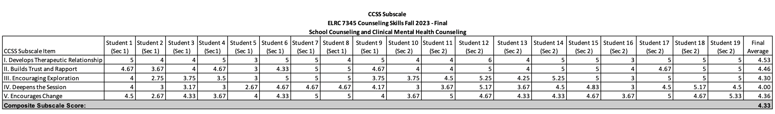

Table 12. SPRING 2024 ELRC 7362 School Counseling Practicum CCSS Subscales Midterm and Final
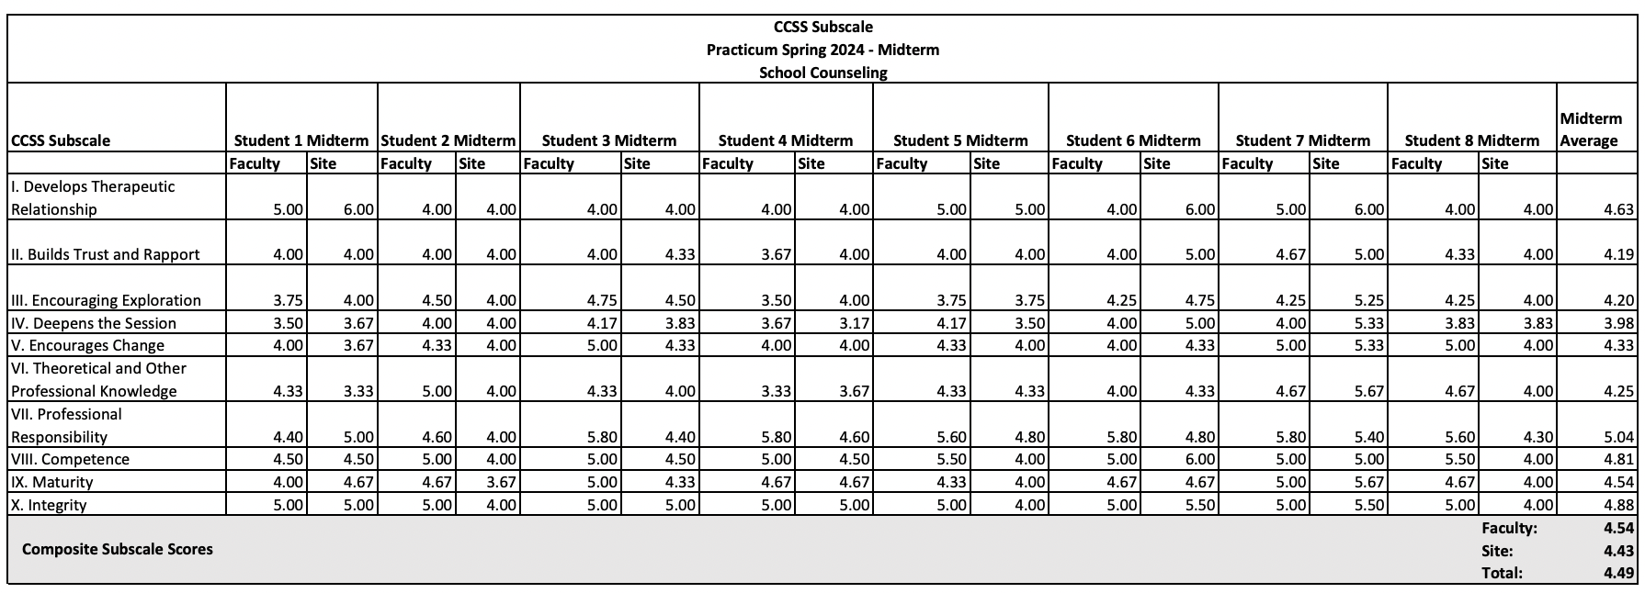
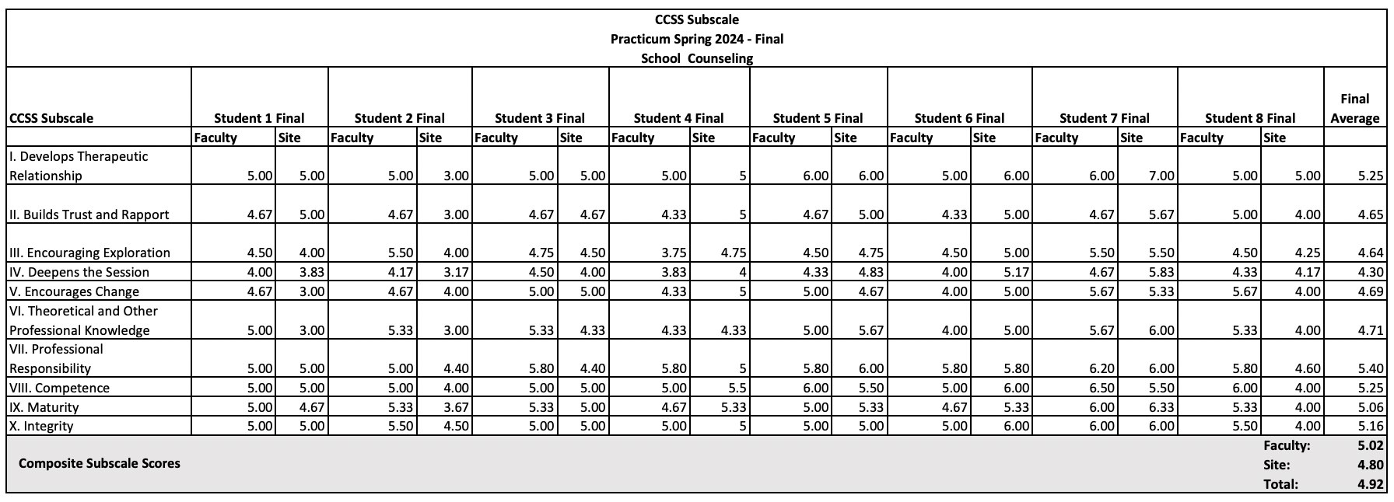
Table 13. SPRING 2024 ELRC 7364 CMHC Practicum Subscales Midterm and Final
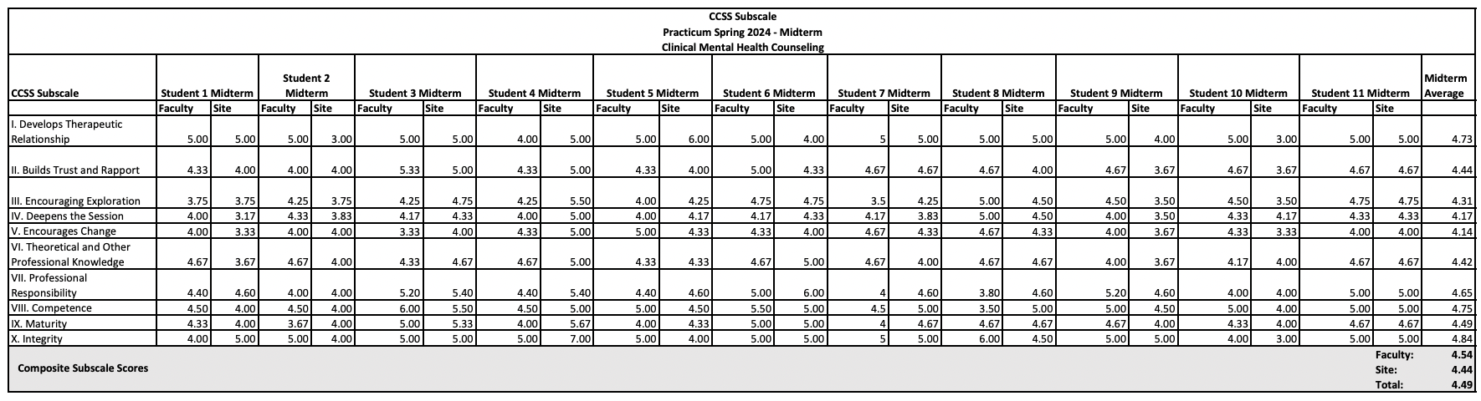
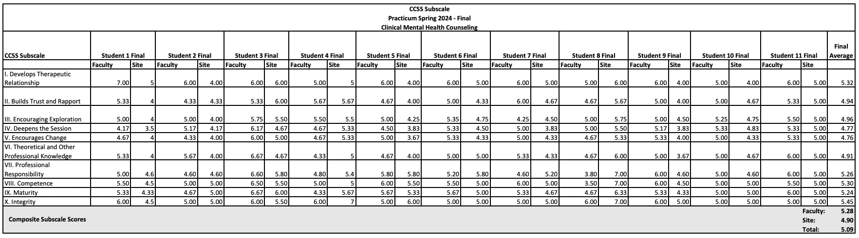

Table 14. FALL 2023 ELRC 7399 School Counseling Internship CCSS Subscales Midterm and Final

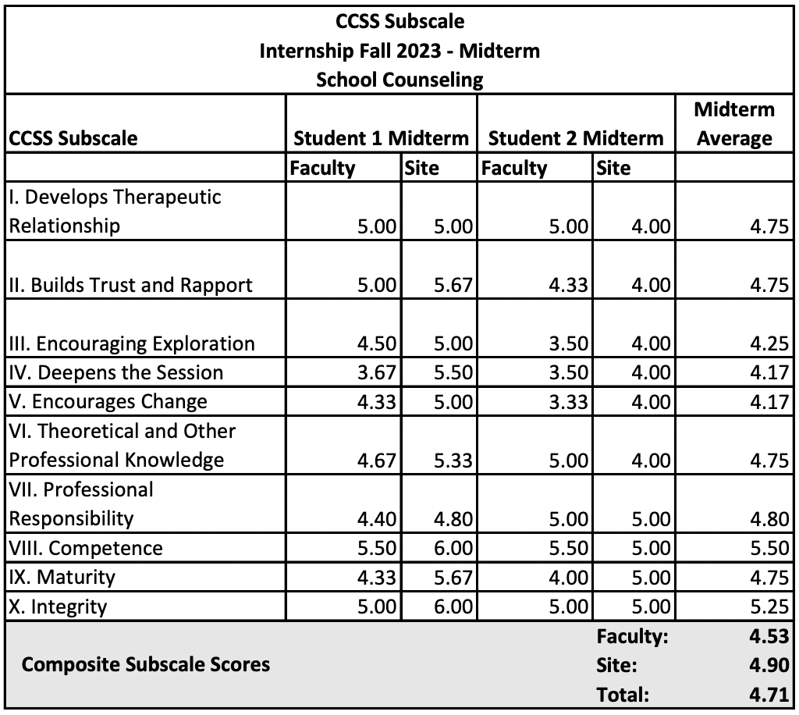
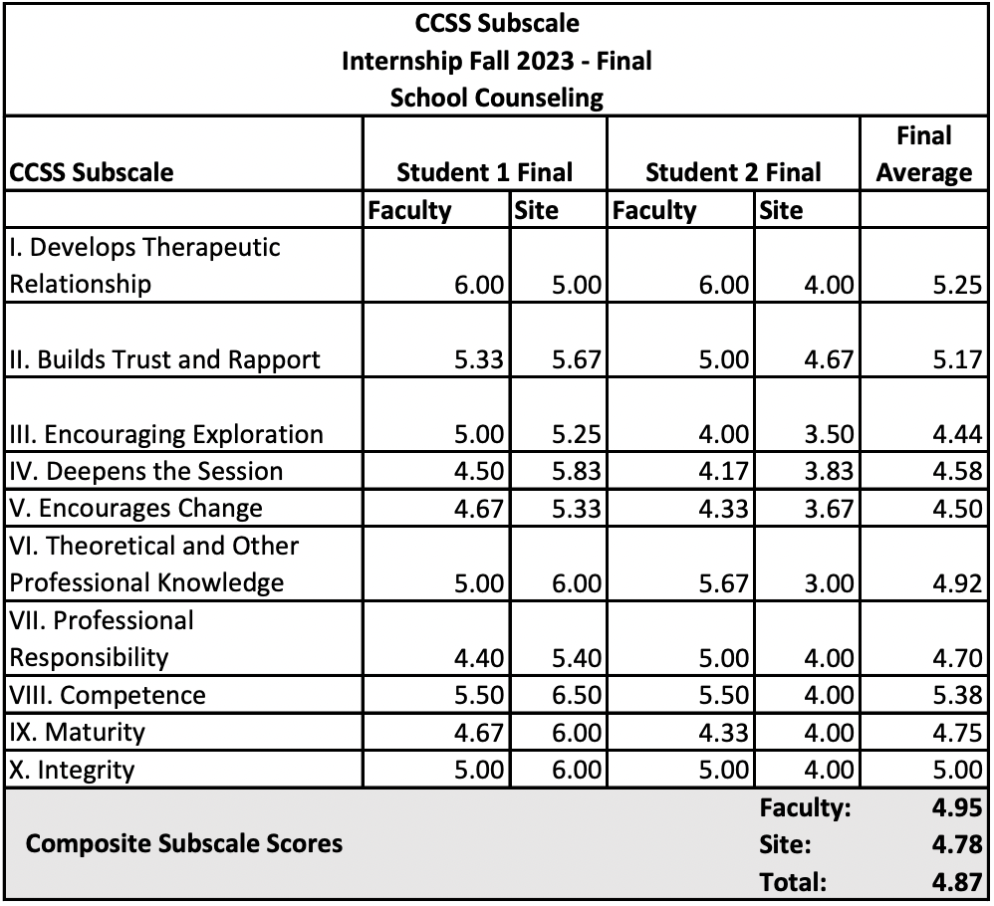

Table 15. FALL 2023 ELRC 7399 CMHC Internship CCSS Subscales Midterm and Final

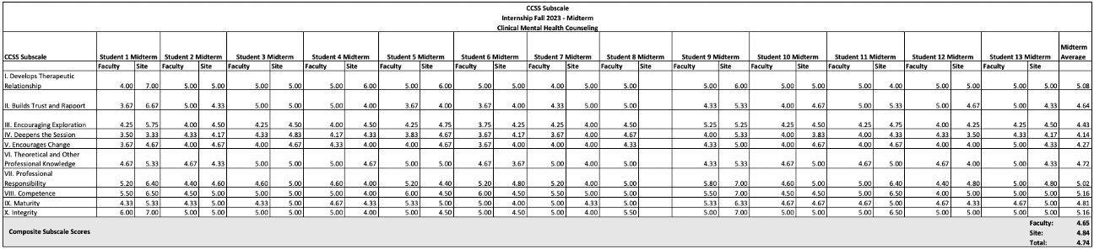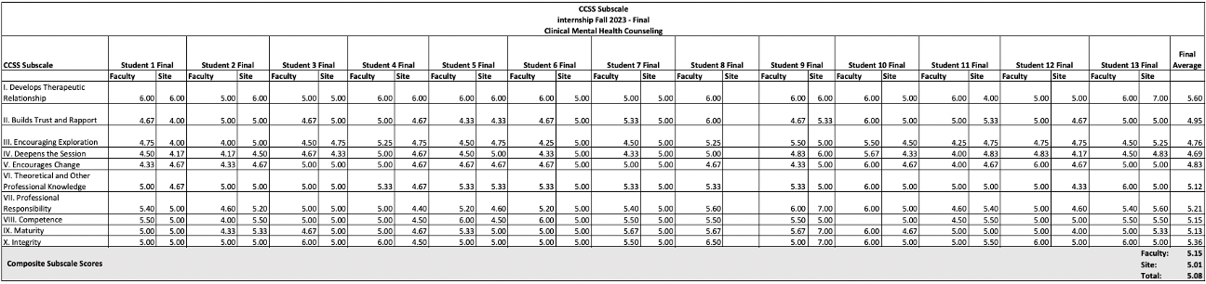

Table 16. SPRING 2024 ELRC7399 School Counseling Internship Subscales Midterm and Final

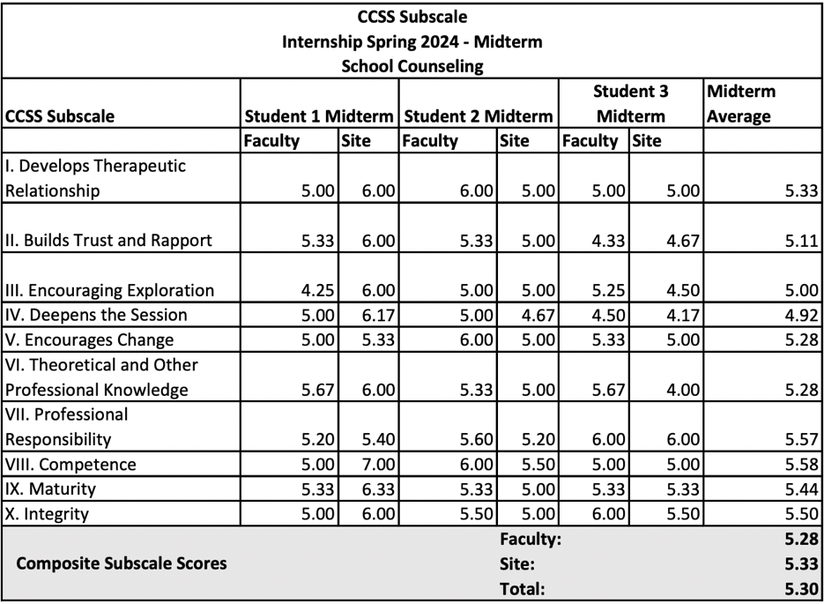
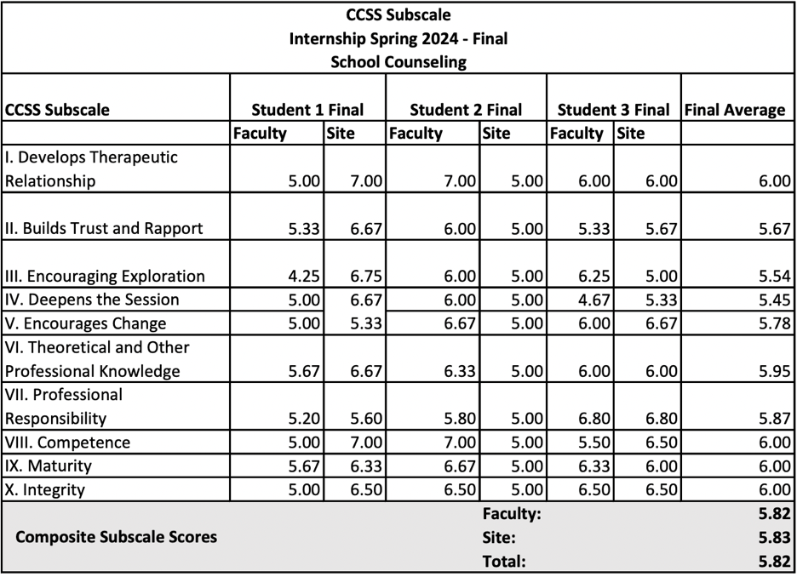
Table 17. SPRING 2024 ELRC 7399 CMHC Internship CCSS Subscales Midterm and Final

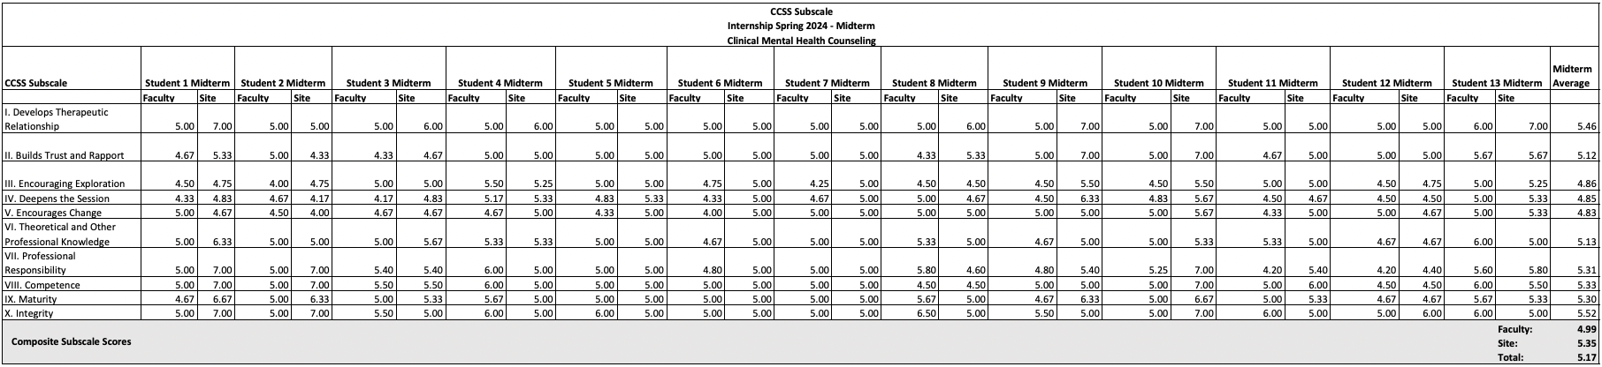

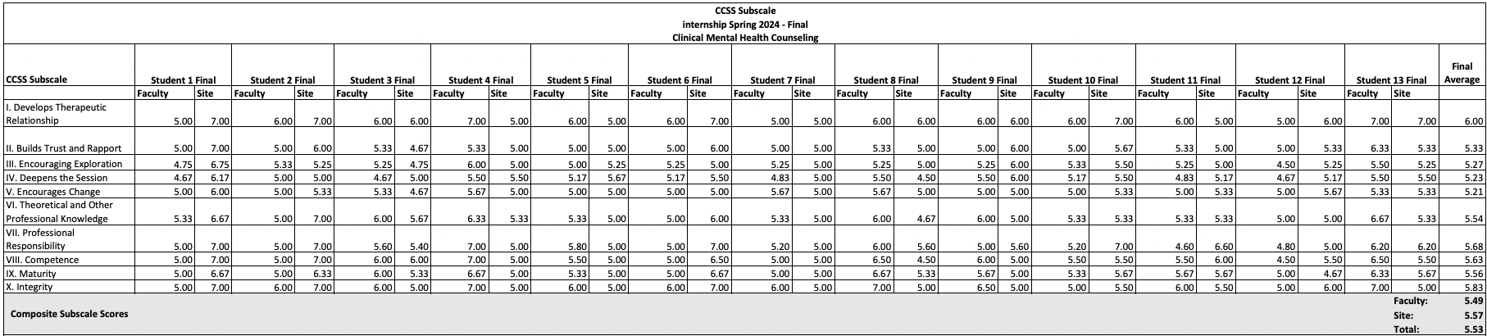

Freeman, B. J., & Garner, C. M. (2017). Professional Dispositions Competency Assessment, Revised. Unpublished instrument, Scholar Works. Garner, C. Freeman, B. Stewart, R. Coll, K. (2020). Assessment of dispositions in program admissions: The professional disposition competence assessment—Revised Admission (PDCA-RA). The Professional Counselor, 10(3), 337–350. doi:10.15241/cg.10.3.337

